Table of Contents

  - Inverting Operational Amplifier
  - Non Inverting Operational Amplifier
  - Summing Amplifier -Adder
  - Subtractor Amplifier
  - Differentiator
  - Integrator
  - Differential Amplifier
  - DAC Using Operational Am plifier
  - Logarithmic Amplifier
  - Monostable Multivibrator -IC 555 timer
  - Astable Multivibrator -IC 555 timer
Non-Liner Operational Amplifier

Experiment 10
Inverting Amplifier
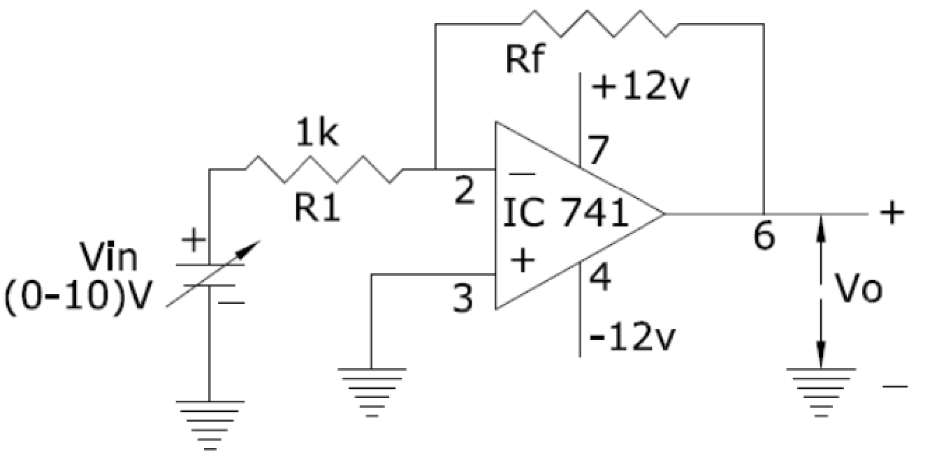

Experiment 11

Non Inverting Amplifier

CIRCUIT DIAGRAM:
10k
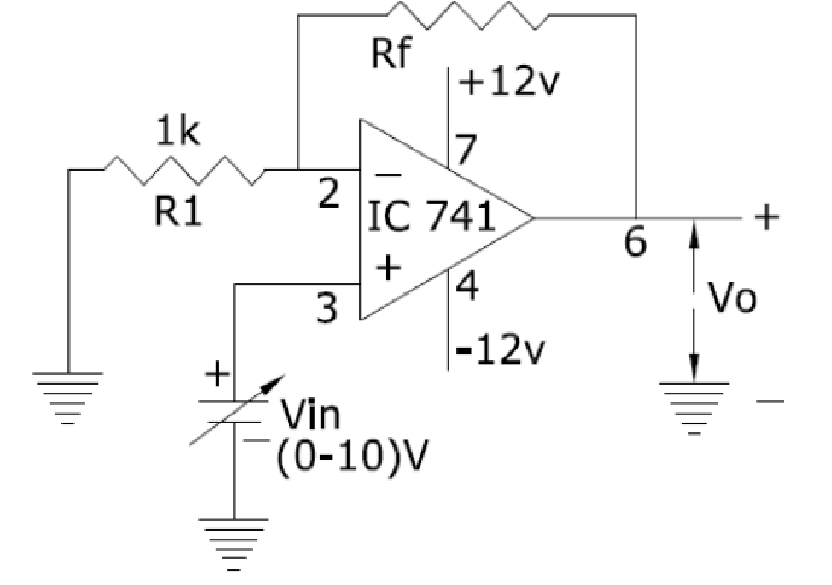

Experiment 12

Summing Amplifier

CIRCUIT DIAGRAM:

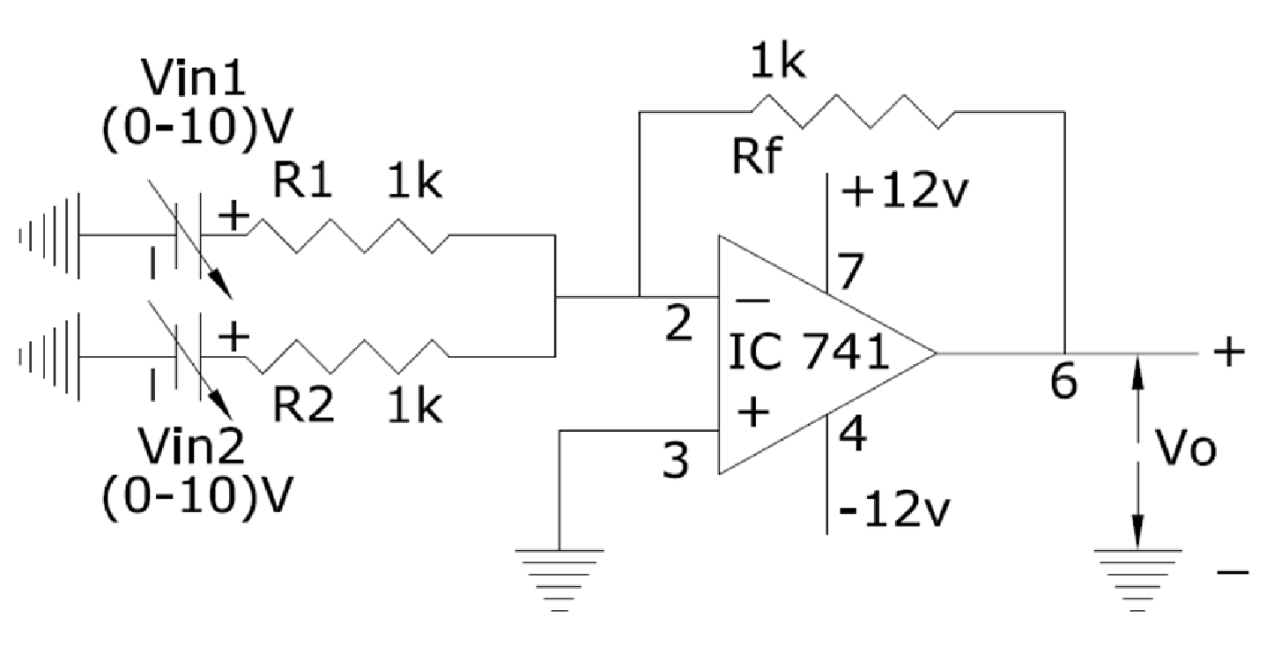

Experiment 13

Differentce Amplifier-Subtractor
CIRCUIT DIAGRAM:

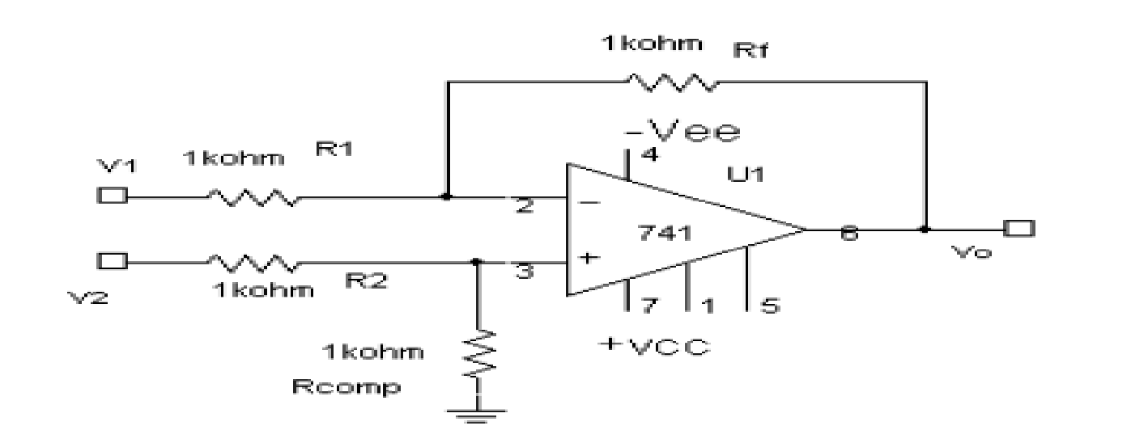

Experiment 14
INTEGRATOR

CIRCUIT DIAGRAM:

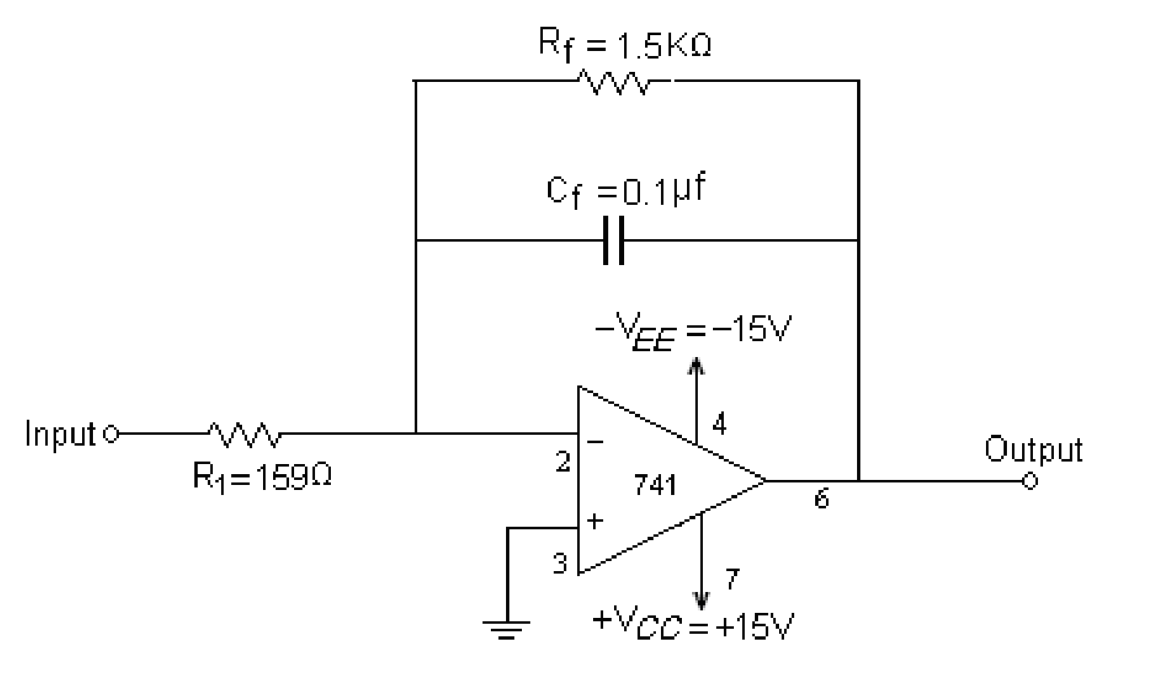

Experiment 15

Differentiator

CIRCUIT DIAGRAM:

Rf =10K
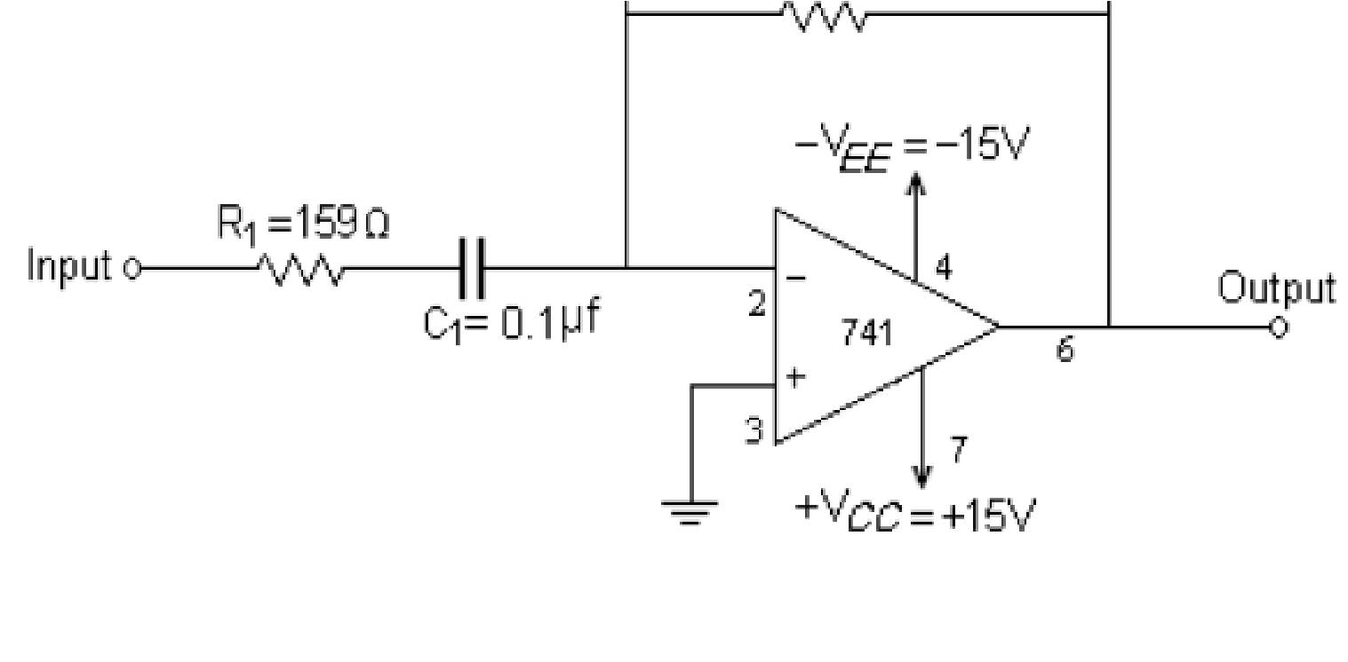

Experiment 16
VOLTAGE FOLLOWER

CIRCUIT DIAGRAM:

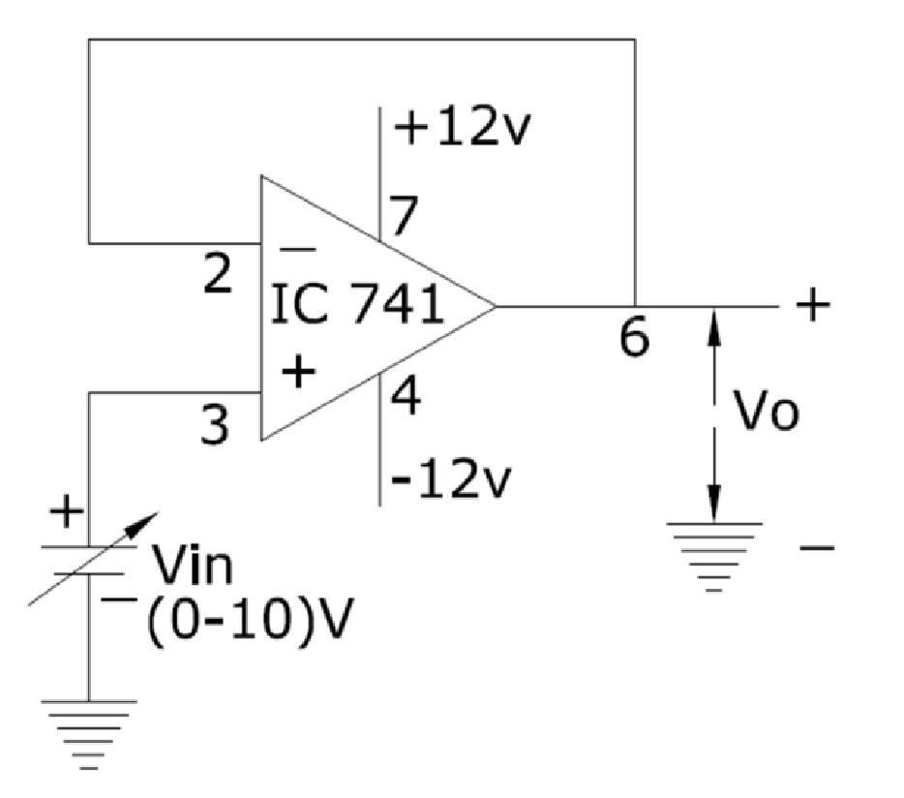

Experiment .No.17
DIFFERENTIAL AMPLIFIER

CIRCUIT DIAGRAM:
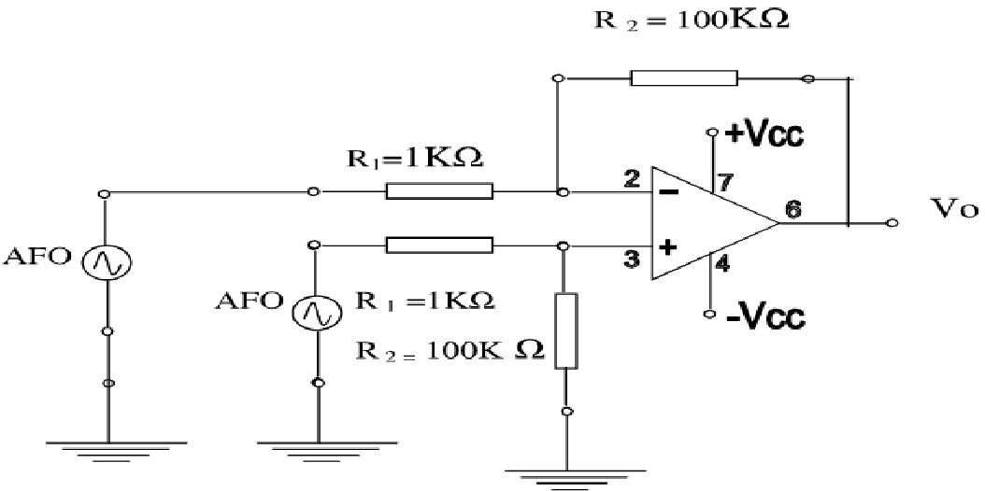

Experiment No.18
DAC Using Operational Amplifier

CIRCUIT DIAGRAM:
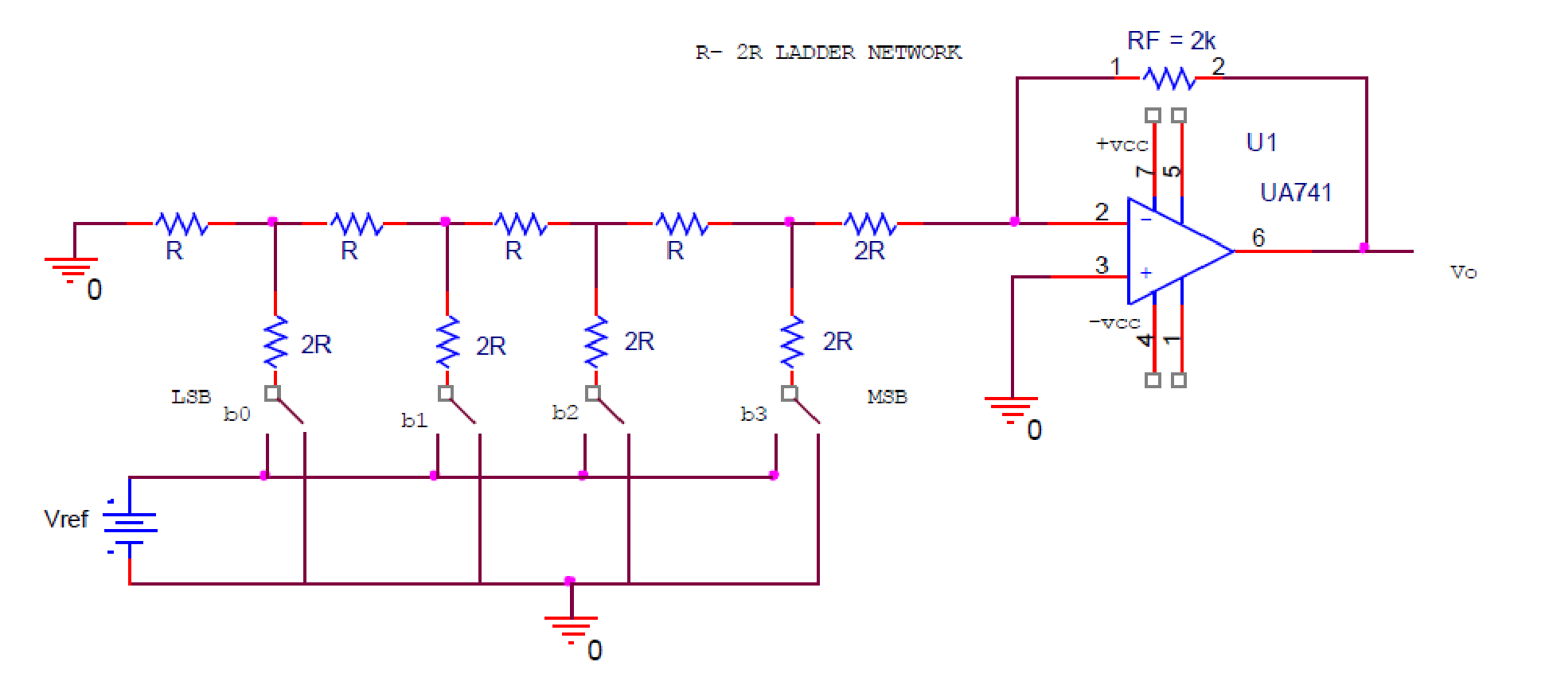

Experiment .No.19
Logarithmic Amplifier

CIRCUIT DIAGRAM:

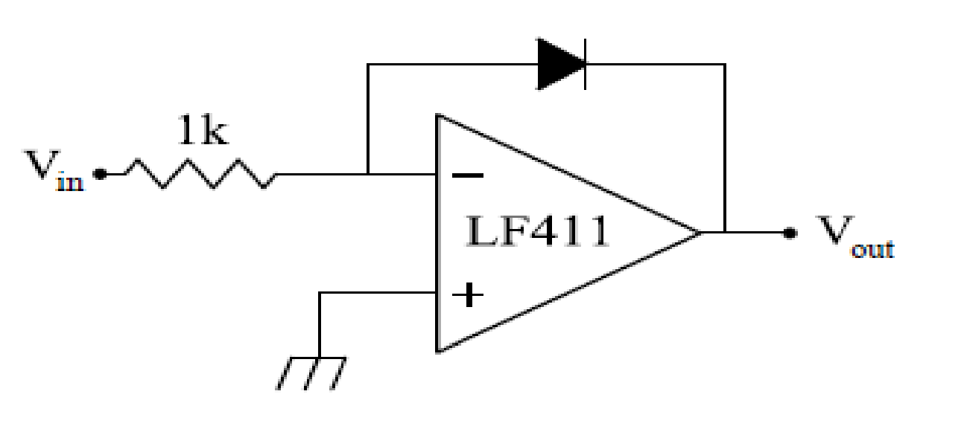

Fig: Logarithmic amplifier configuration of op-amp

Experiment 20
Mono-Stable Multivbrator -IC 555 Timer

CIRCUIT DIAGRAM:
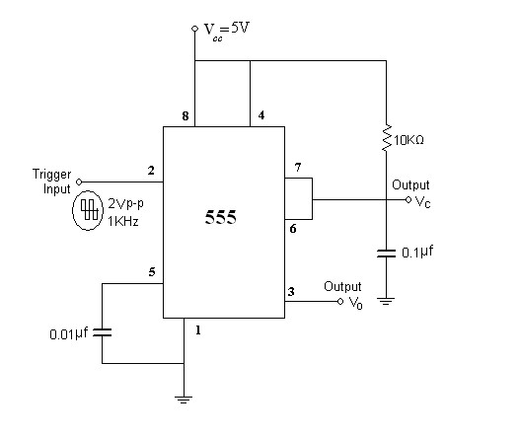

Experiment 21

Astable Multivibrator -IC 555 Timer
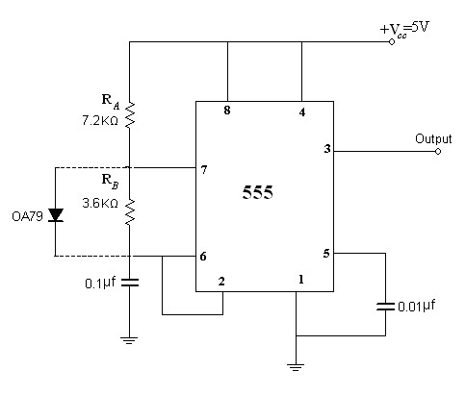

Experiment No.22
Liner Op-Amp Circuit
Introduction

Active half wave rectifier:

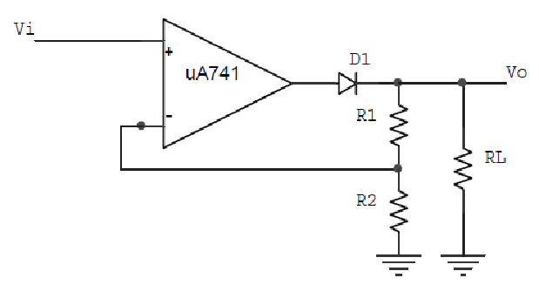

Active clipper:

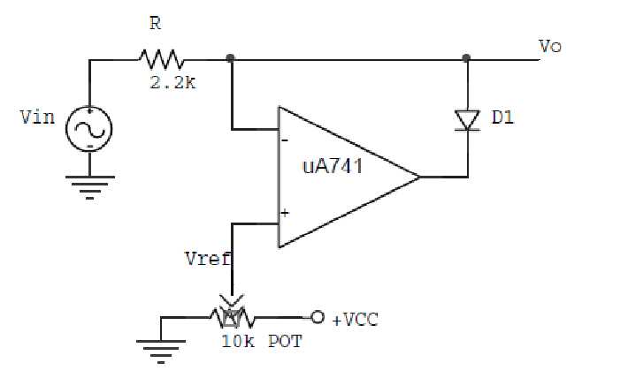

Active clamper:

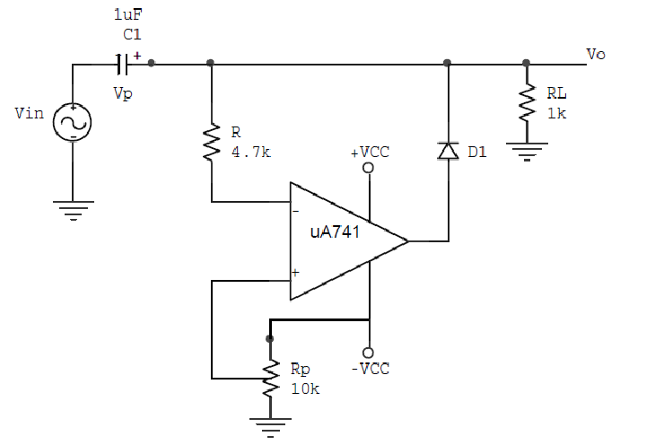

CIRCUIT DIAGRAM:

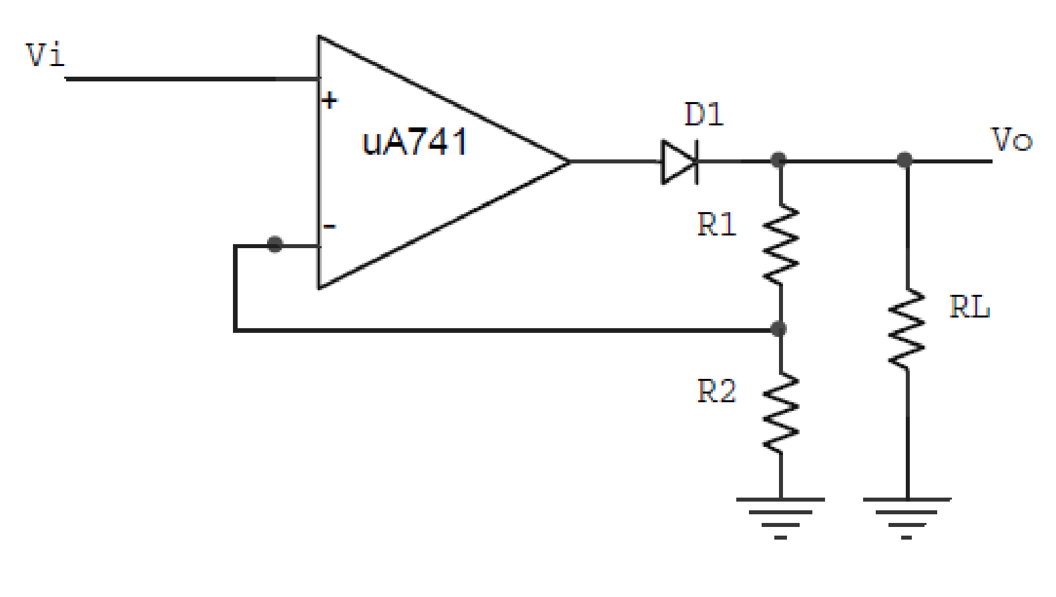
Circuit Diagram1: Circuit for Active Half Wave Rectifier.

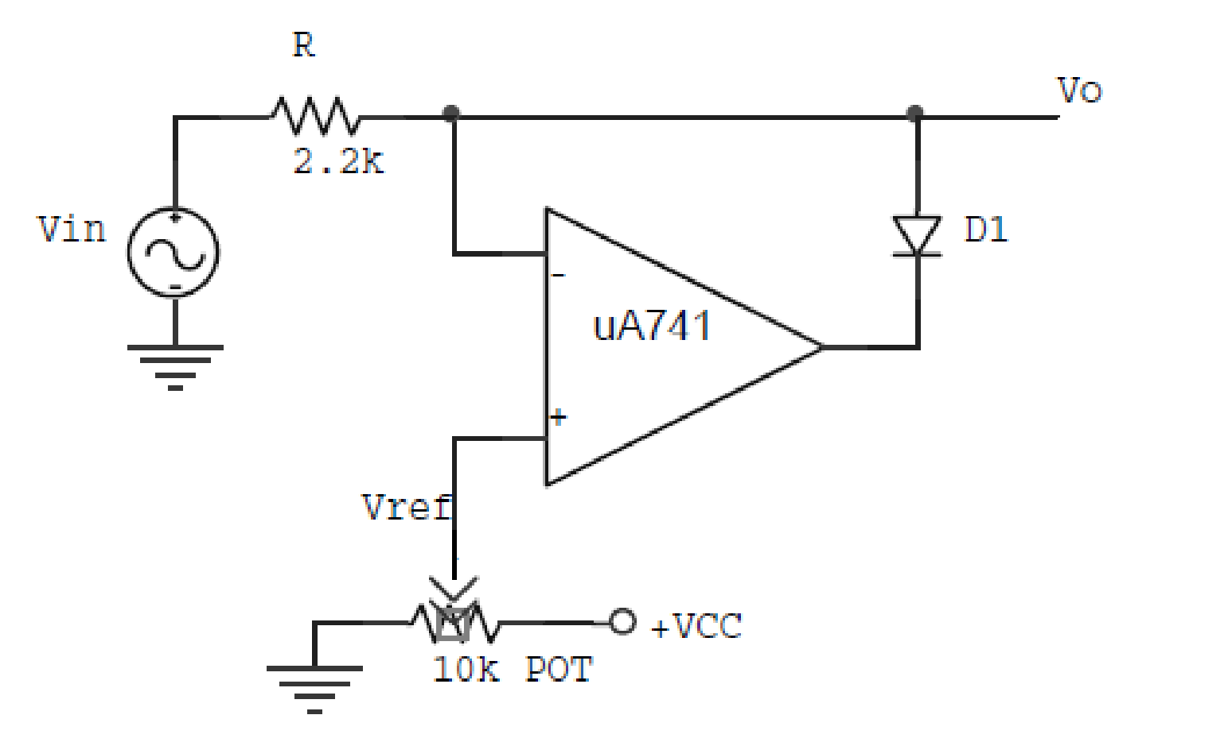
Circuit Diagram 2: Circuit for Active Clipper

